How to Create a Server in AWS (EC2 Instance)
1. Log In to AWS
- Go to the AWS Management Console.
- Sign in using your AWS account.
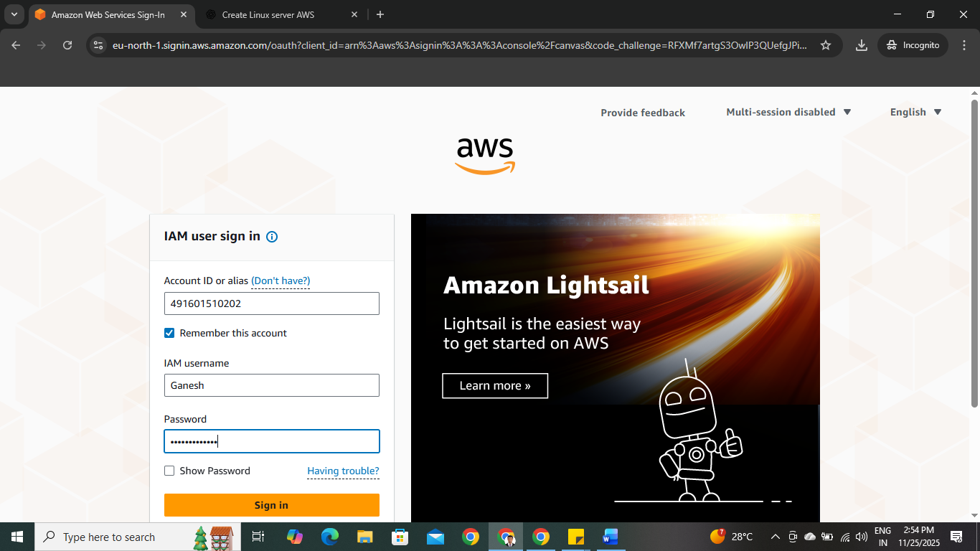

2. Open EC2 Dashboard
- In the search bar, type EC2.
- Click EC2 (Elastic Compute Cloud).
Why this step matters
- EC2 (Elastic Compute Cloud) is the AWS service that lets you create and manage virtual servers. All server-related operations start here.

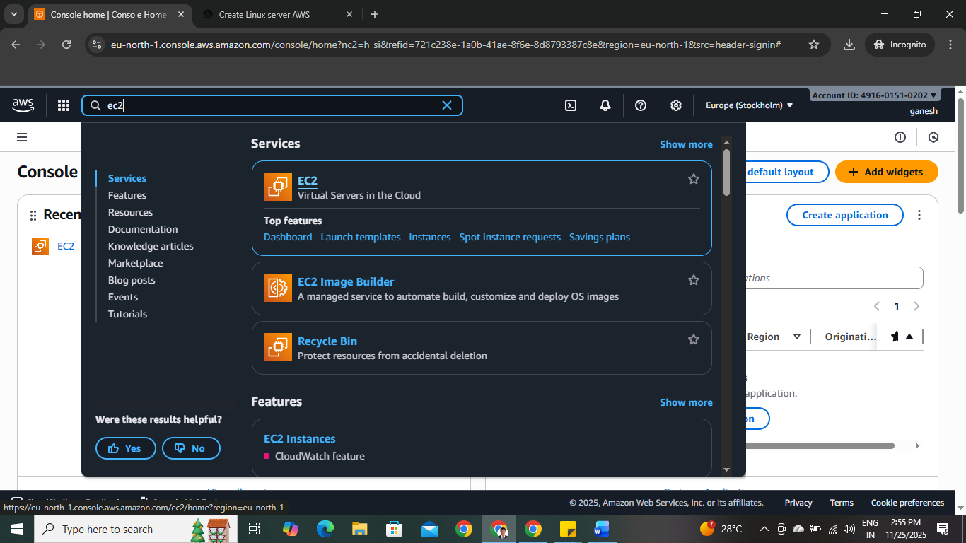
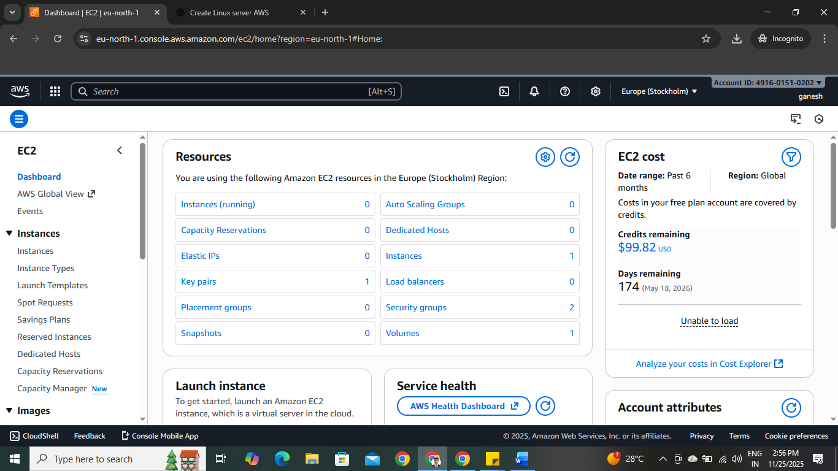

3.Launch a New EC2 Instance
Once you're inside the EC2 dashboard:
- Click Instances on the left navigation pane
- Click the Launch Instance button
Why this step matters
“Launching an instance” is AWS’s term for creating a new virtual server. This begins the setup process.

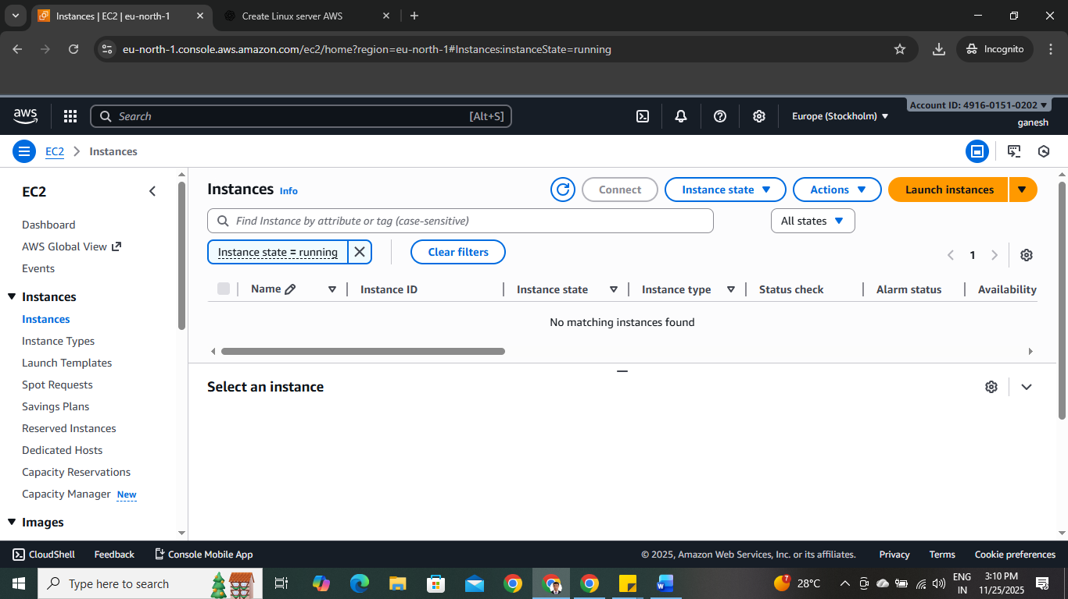

4. Configure Your Instance
When launching the instance, AWS will present several configuration sections.
4a. Name Your Instance
Give your instance a name like:
- linux-server
- web-server-prod
- C5-ubuntu-server
Why this matters
Naming helps you easily identify your server later, especially if you manage multiple instances.
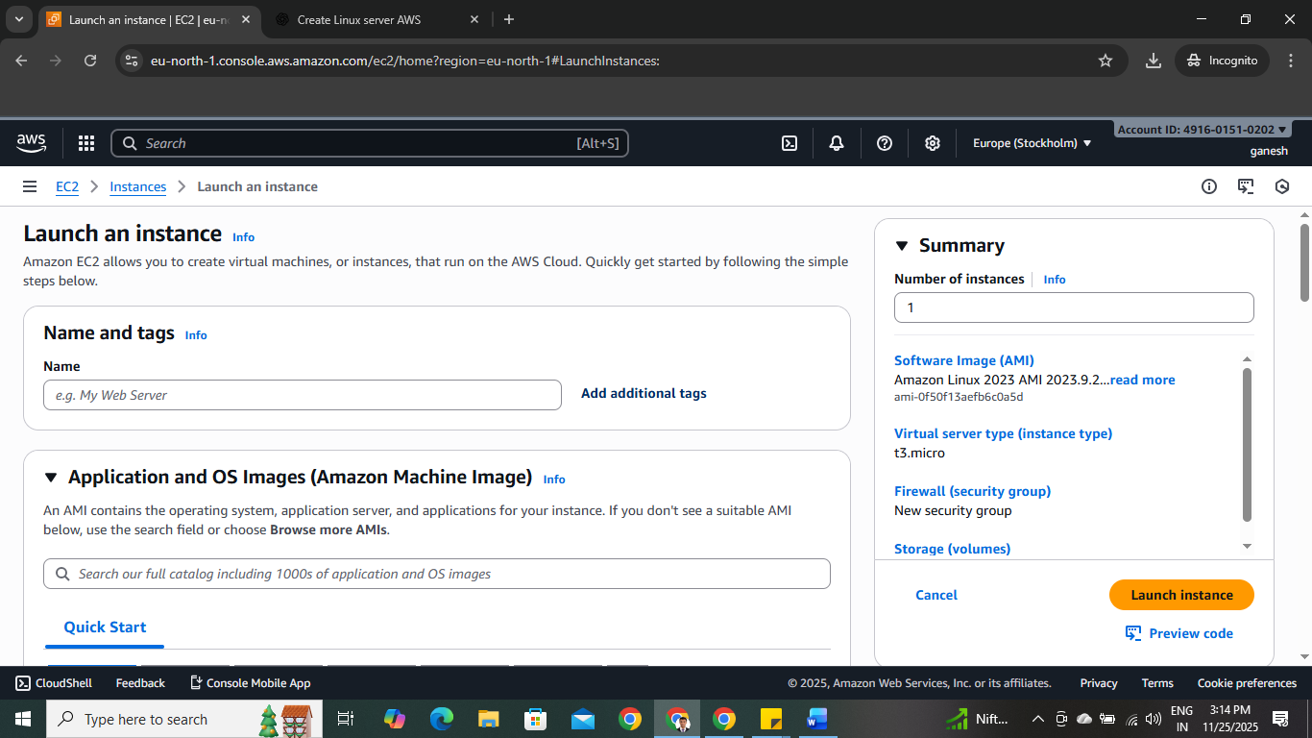

4b. Choose an AMI (Amazon Machine Image)
The AMI defines the operating system and base software installed on your server.
Common Linux choices:
- Amazon Linux (optimized for AWS, free-tier eligible)
- Ubuntu
- Red Hat Enterprise Linux (RHEL)
- Debian
Why this matters
The AMI determines:
- OS type
- Default user for SSH
- Security updates
Choose the one that fits your project or organizational needs.
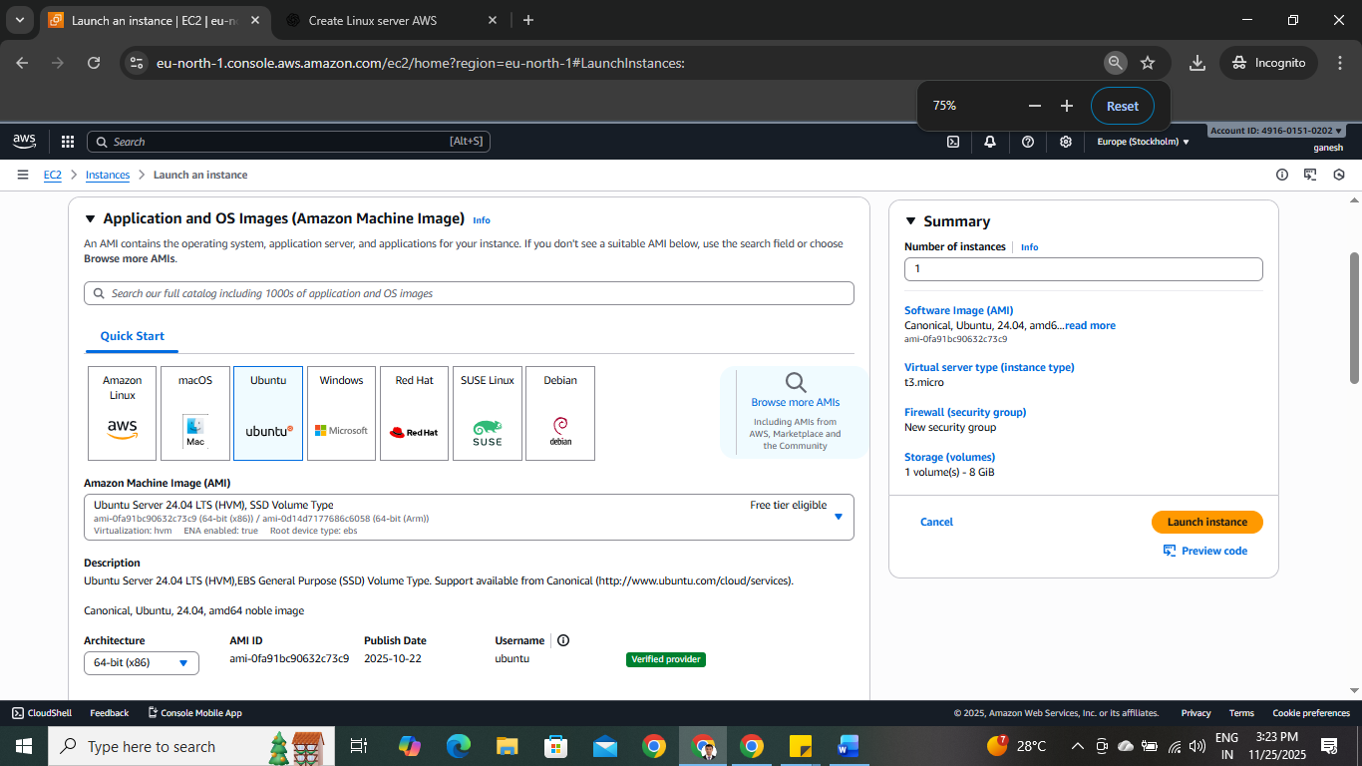

4c. Choose Instance Type
Instance types define CPU, memory, networking, and performance.
Common options:
- t2.micro (free-tier eligible)
- t3.micro (newer, more efficient, free-tier eligible for some accounts)
- Larger types like t3.medium, m5.large for production loads
Why this matters
Bigger instance types = more power, but also higher cost. For learning and small projects, t2.micro/t3.micro is enough.
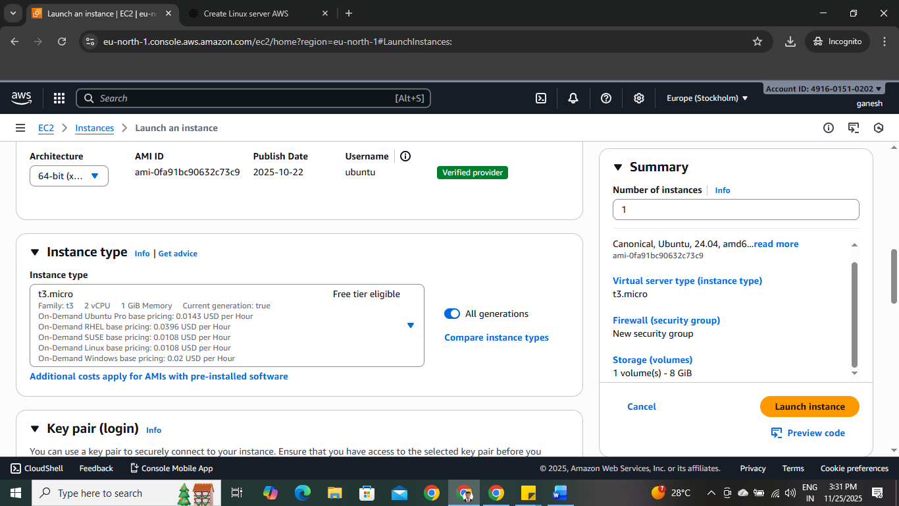

Connect to instance using

5. Create or Select a Key Pair
AWS will ask you to attach a key pair. This is how you will securely SSH into the server.
- If you don’t already have one, click Create new key pair
- Choose:
  - Key type: RSA
  - File format:
    - .pem (Linux/macOS)
    - .ppk (Windows PuTTY users)
- Click Create key pair to download it
Why this matters
This key pair is your only way to log in. If you lose it, you cannot SSH into the server unless you take advanced recovery actions.

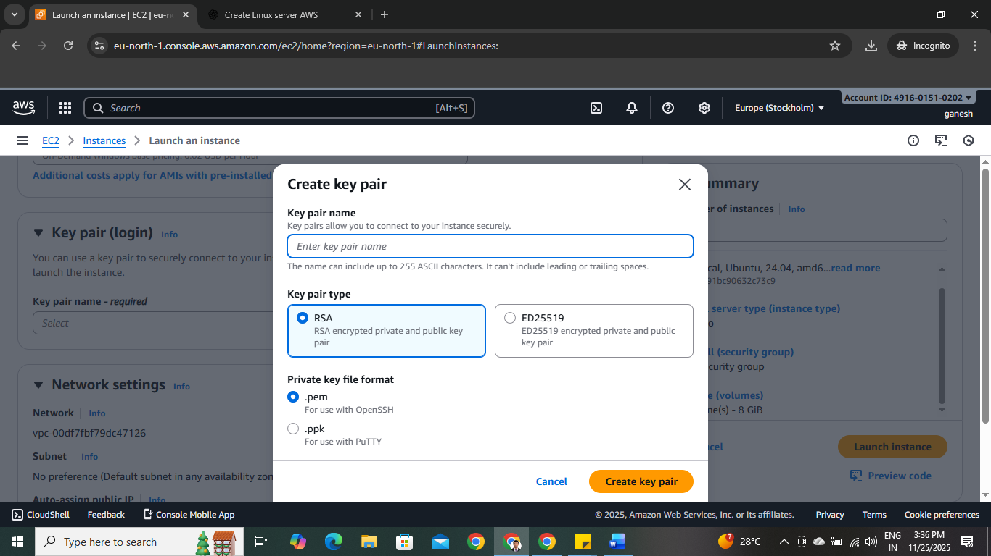

6. Configure Network Settings
AWS will present default settings for Security Groups.
Typical configuration:
- Allow SSH (port 22) from:
  - My IP (recommended — secure)
  - 0.0.0.0/0 (NOT recommended — allows anyone to attempt login)
Why this matters
Security Groups act as a firewall. They control what traffic can access your server. Correct configuration is essential for security.

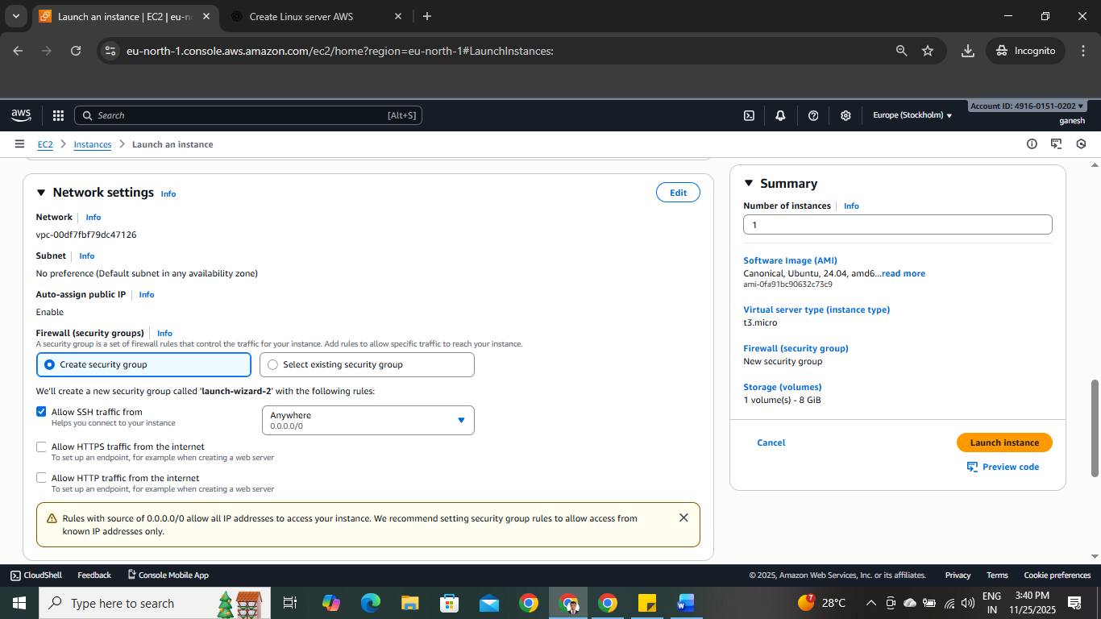

7. Configure Storage
AWS attaches an EBS (Elastic Block Store) disk to your instance.
Default:
- 8 GB gp3 SSD
You may increase to 20GB, 30GB, or more depending on your application.
Why this matters
This storage will hold your OS, files, applications, logs, and data.
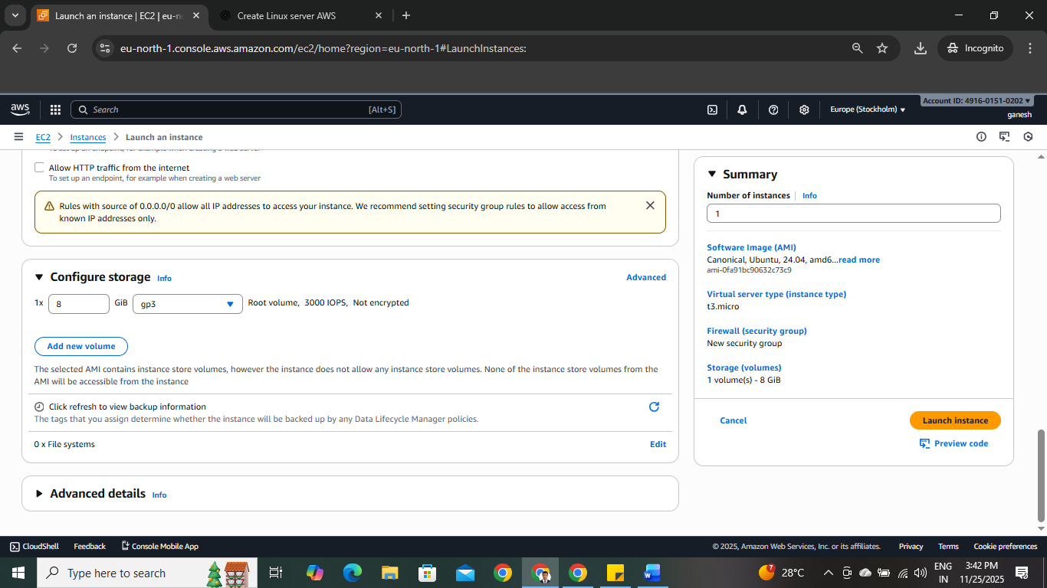

8. Launch the Instance
After reviewing the settings, click:
Launch instance
AWS will now:
- Create the virtual machine
- Provision storage
- Assign networking
- Attach the key pair
Why this matters
This finalizes the creation of your Linux server.

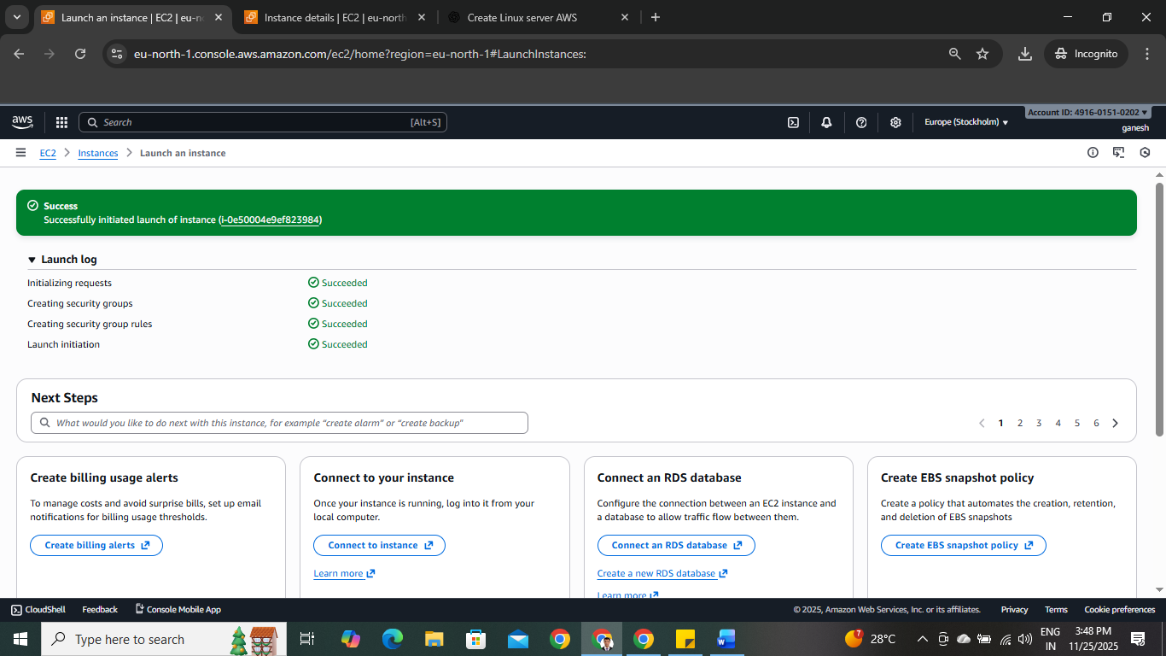

Connect to the Server via SSH
Step 1: Get the Public IP
- Go to EC2 → Instances
- Select your instance
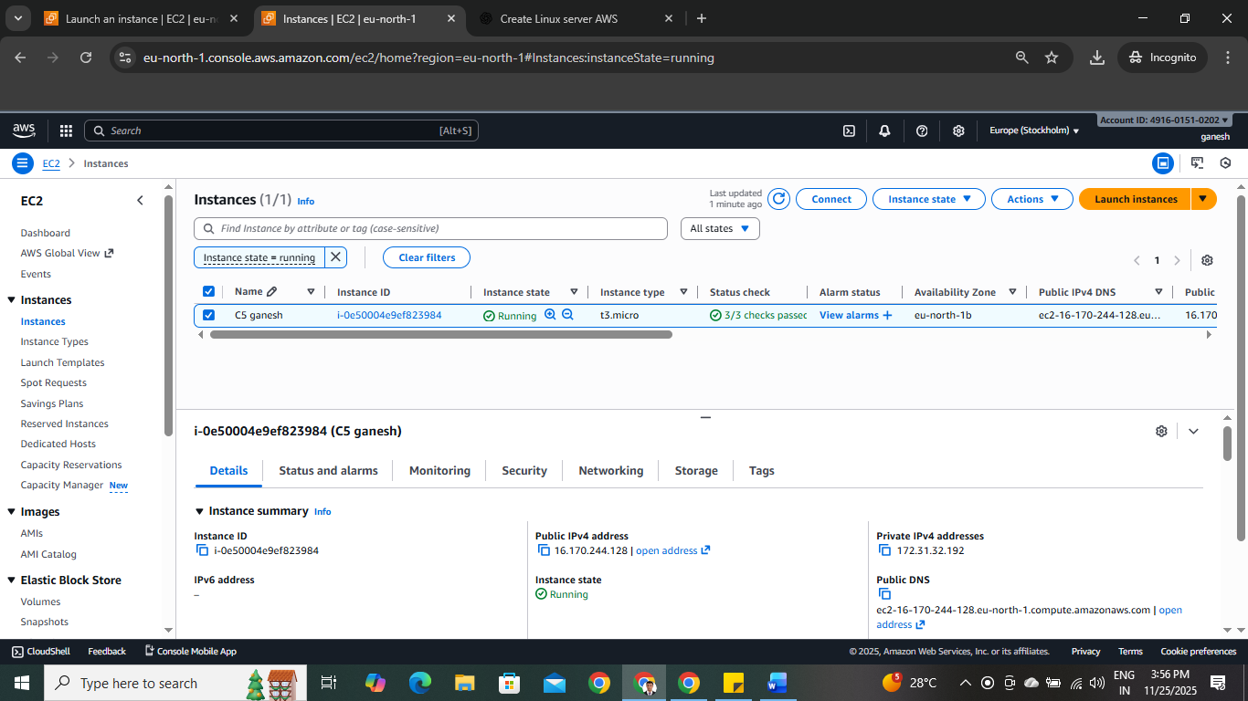
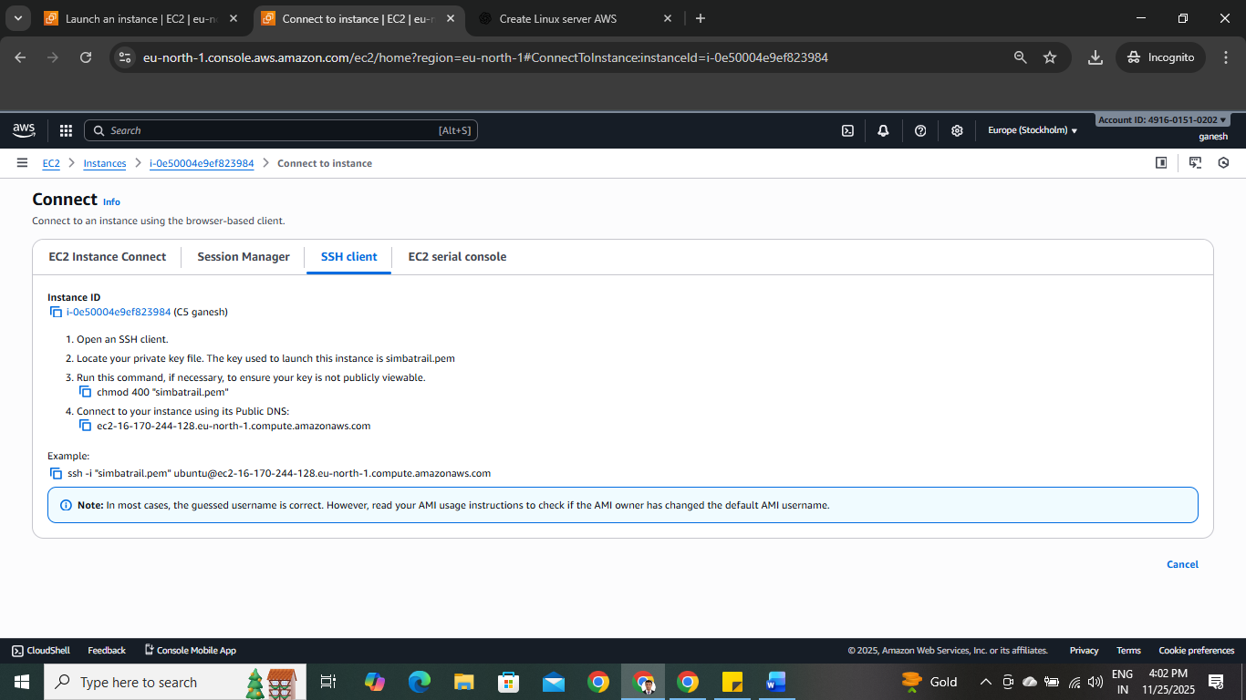
Connect Instance via SSH using PowerShell
Click Start, type PowerShell, click Windows PowerShell, and then click Run as Administrator.
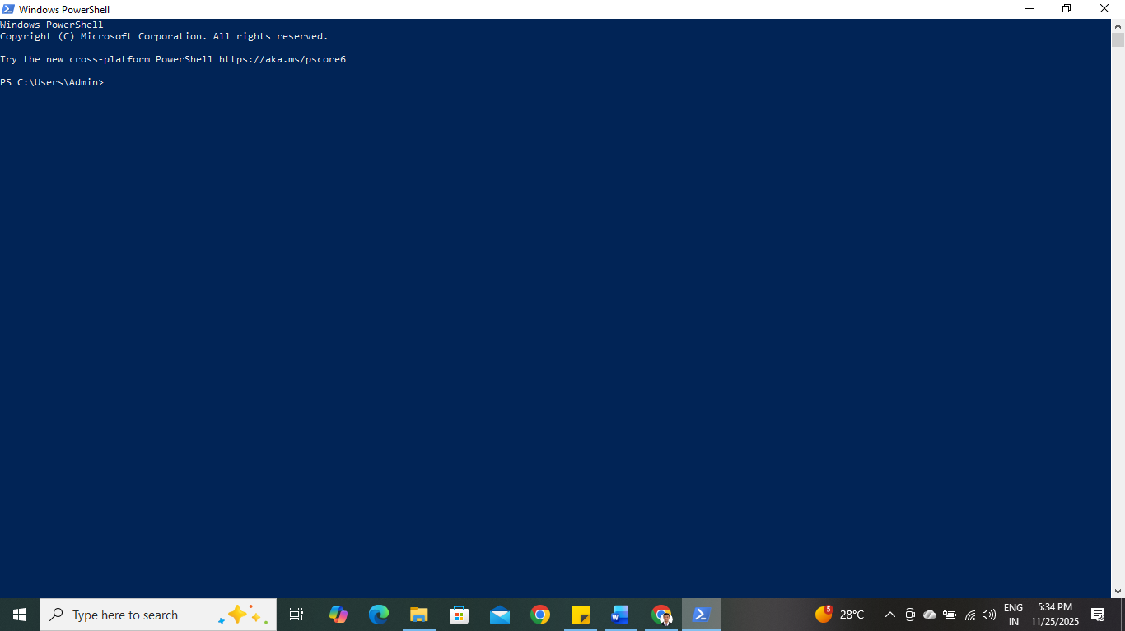
Chek path by using Pwd command
Run pwd to see your current path, then run ls to list all files and folders in that location.
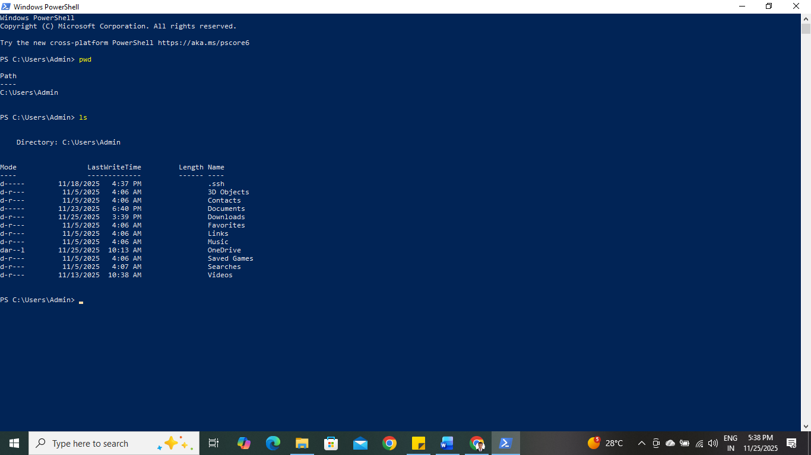
Changed to the download’s directory
PS C:\Users\Admin> cd downloads 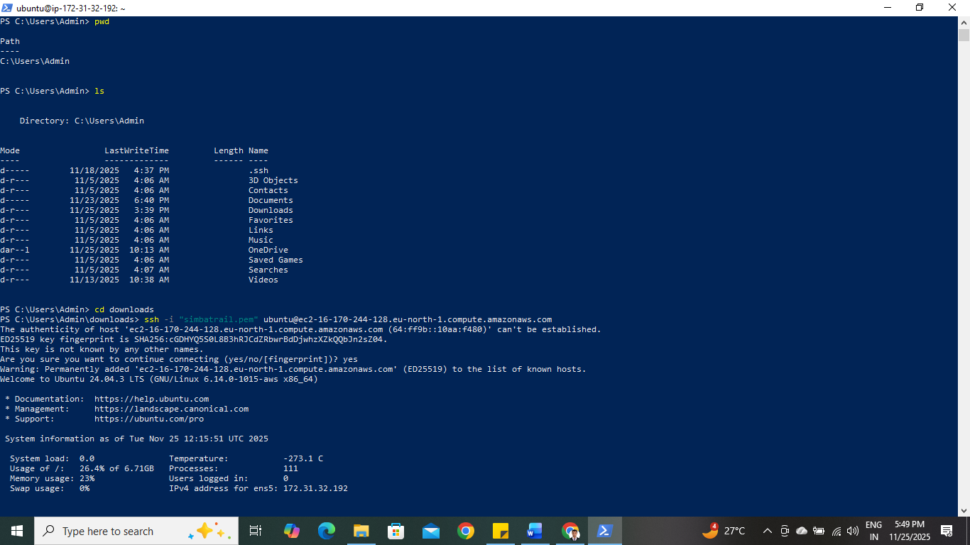
Navigate to the folder containing the key
I navigated to the Downloads directory where my key file is stored, and then used the key to connect.
the key matches the server,
Instances connected suceesfully.



